**Microprocessor Lab**

Laboratory Activity No. 2

**Arduino and Tinkercad Interface**

|  |
| --- |
|  |

Score

*Submitted by:*

**Muñoz, Kerwin C.**

**<Saturday 7:00am – 1:00pm> / <CPE 0412-1>**

*Date Submitted*

**09/30/2023**

*Submitted to:*

**Engr. Maria Rizette H. Sayo**

I. Objectives

This laboratory activity aims to implement the principles and techniques of hardware programming using Arduino through:

- creating an Arduino programming and circuit diagram.

II. Method/s

- Perform a task problem given in the presentation.

- Write a code and perform an Arduino circuit diagram of a ring counter that display

eight (8)LEDs starting from left.

III. Results

**TinkerCad**

**Exercise 1: Write a code that does a ring counter display for eight (8) LEDs starting from left.**

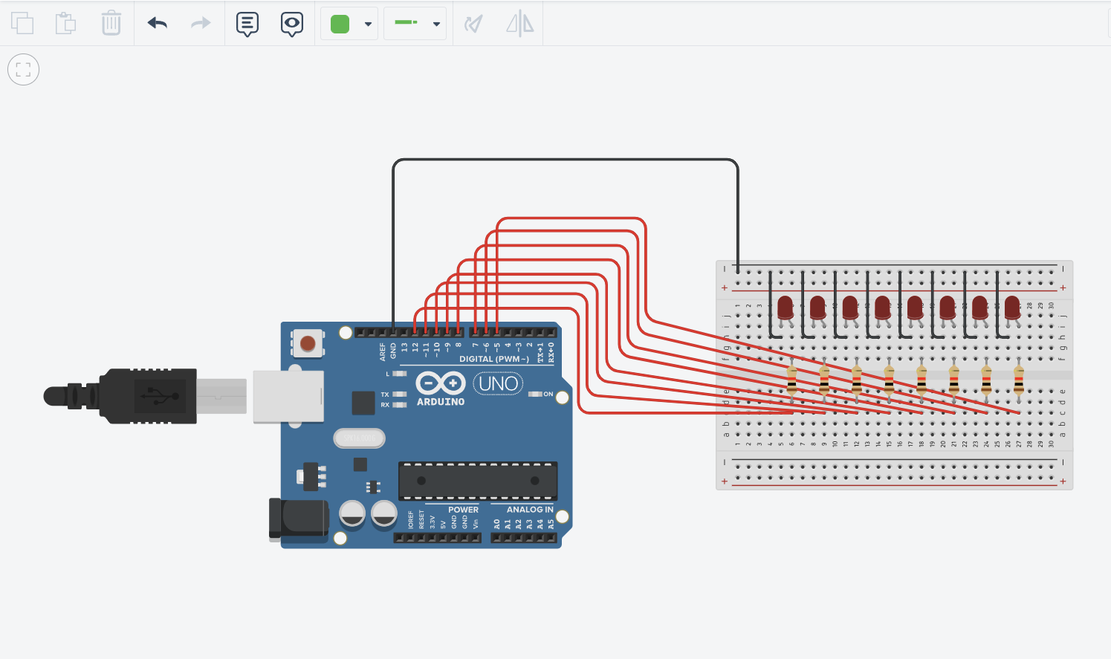

Figure No.1 Ring Counter Display Circuit Diagram

**Components Used**

1. 8 LEDs
2. Resistor
3. Breadboard

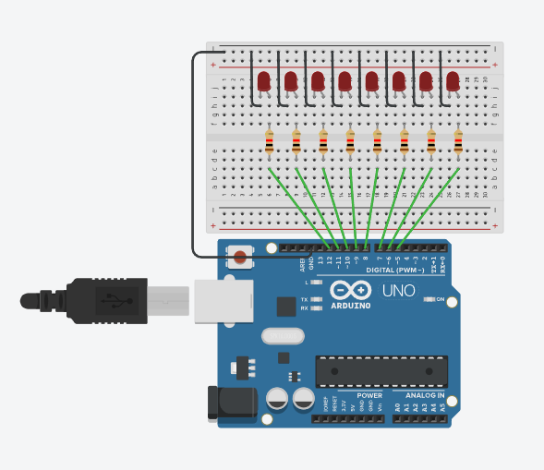

**CODE:**

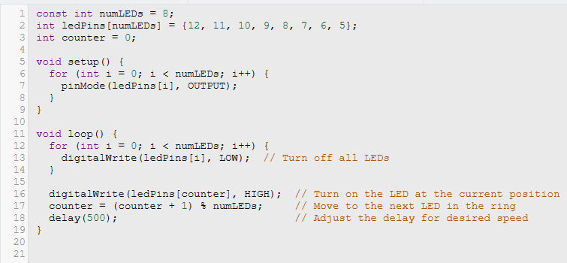

IV. Conclusion

In this engaging activity, we embarked on an exciting journey to create a mesmerizing ring counter display using eight LEDs, all within the virtual realm of Tinkercad. The aim was to design a visually captivating sequence where each LED lights up in a delightful order, creating a visually pleasing loop of light.

First, we set up an array to keep track of the LED pins, ensuring a neat and organized approach to managing our hardware. Next, a counter was employed to elegantly cycle through the LEDs, one after the other, achieving that charming ring-like effect.

As our code ran its course, each LED took its turn to shine, gracefully lighting up and then dimming down, passing the light to its neighboring LED. The LEDs danced in unison, showcasing a seamless and mesmerizing display that caught the eye and brought a smile to our faces.

This activity not only showcased the technical prowess of leveraging microcontrollers and programming but also provided a glimpse into the creative and artistic side of engineering. It's a testament to how technology can blend seamlessly with aesthetics, resulting in a delightful and visually appealing outcome. It was a delightful journey indeed, demonstrating the magic that unfolds when we combine creativity with code.

**References**

[1] D.J.D. Sayo. “University of the City of Manila Computer Engineering Department Honor Code,” PLM-CpE Departmental Policies, 2020.

*<This is in a separate page>*